# *Globetrotting(Tourism Management System)*

*Author*

M.Muneeb

## 1. Introduction

* **Purpose of this document**

The purpose of this document is to present a detailed description of the Tourism management System. It will explain the purpose and features of the system, the interfaces of the system, what the system will do, the constraints under which it must operate and how the system will react to external stimuli. This document is intended for both the stakeholders and the developers of the system.

* **Scope of this document**

The Globetrotting project is an implementation of a managing Tourism which helps the customers to search the availability of various tourist places and prices of various hotel rooms in particular places, along with the different packages available with the reservations. This project also covers various features like online registration of the users, modifying the details  by the management staff or administrator of the app, by adding, deleting or modifying the customer details or packages information. In general, this app would be designed to perform like any other Tourist management website available online.

* **Overview**

 This product fulfill user requirement such as it facilitate him to arranging their tour. Provide GPS, arrange their booking.

* **Business Context**

The user faces a great challenge in the age of the information technology development. The traditional tourism distribution channel faces a threat of the emerging IT environment. Throughout years the tourism industry was dependent on the intermediaries, who enabled the interaction between the suppliers and the customers. Nowadays, however, the suppliers can reach the customer directly via internet. By this product user fulfill their requirement without any difficulty from their mobile phones, laptops and social media devices. By using this app user pay monthly or yearly using packages so it is best for business point of view.

## 2. General Description

* **Product Functions**

Thus this system like a self-containing shell that covers all the major aspects in the computerization of tourist agency. Some tasks are described in detail:

Ø  **Sight Seeing Tours:**

Tourist can enjoy, sightseeing tours to any of the place, listed in Agencies Data File. Before that Customer has to make the booking by registering his/her name in Data-File and informing date of journey and No. of operations.

Ø  **Hotels:**

 Agency also makes the reservation for the Hotels registered with agency.

Ø  **Billing:**

Once the Customer makes the booking or reservation, Bill will be generated for him/her, and money has to be paid on the spot itself.

Ø  **Report Generation/Feedback**:

Details about the locations, hotels in that location and final report on the journey fare.

* **Similar System Information**

Pakistan tourism app is also similar with this product but it doesn’t provide some of the feature which ours product provide such hotels booking, airline booking, convert currency from their mobile without going to any agent.

* **User Characteristics**

**Customer**: The one who uses the system. For which the system is created. E.g. tourist, end users

**Manager:** The one who manages the system, provide details to the customers

**Administrator**: The one, who operates the system, modifies, add or delete the customer records in databases. Customer Search location manager Manages system Admin Operates system

* **User Problem Statement**

The user faces a great challenge in the age of the information technology development. The traditional tourism distribution channel faces a threat of the emerging IT environment. Throughout years the tourism industry was dependent on the intermediaries, who enabled the interaction between the suppliers and the customers. Nowadays, however, the suppliers can reach the customer directly via internet having the geographical distance barriers and costs associated to them, disappeared. The internet age changed the complexity of the user, enabling the entry of the new virtual intermediaries characterized by a strong competitive advantage towards other players of the sector.

* **User Objectives:**

These are the same objective which user requires and our product fulfill.

Ø  Airline booking from their phones

Ø  Hotel booking

Ø  Maps

Ø  Emergency service

Ø  Tourist spot

* **General Constraints**

List of a constraint which faces our designing, implementation team such as

Ø  They gather the entire requirement from stakeholder.

Ø  Design them.

Ø  Implementation team faces time constrain such they complete first iteration in their time period

Ø  Speed constrain in which they make this product fast that it can response user in nanosecond.

## 3. Functional Requirements

Ø  The client must register for create the account and login using username and password to use function in the application

Ø  _ collect data of client personal information (name, address, tel number, old, behavior)

Ø  – The client can view or find the information of hotel, tourist attraction.

Ø  – The client can search for booking hotel, flight after select date time to go.

Ø  – The client can find the information and the calculate system of time, ways, price to the destination place.

**<Name of second highest ranked requirement>**

Second highest ranked requirement is currency conversion.

## 4. Interface Requirements

* **Hardware Interfaces**

Hardware specification

Processor: Pentium IV

Speed: 2.0 GHZ above

Hard Disk: 40 GB RAM: 512 MB

CD Drive: 48 xs

Input devices: Keyboard and mouse

Monitor: Compatible monitor with 600 x 800 resolutions

Internet: 100kbps above

Printer: Any printer compatible for Windows

* **Software Interfaces**

Software specification

Operating System: Windows XP or Higher versions

Front End: ASP.NET

Back End: SQL

## 5. Performance Requirements

## Stakeholder requires that system should response on less than 1 nanosecond and if system fails then it reboot itself and recover itself.

## 6. Design Constraints

* **Hardware Limitations**

This system does not works on mobile phones which have ram less than 1 GB and also does not support computer which have less than 80GB rom.

Ø  Processor _at least 2.0GHZ

Ø  RAM _at least 2 GB

## 7. Other non-functional attributes

Specifies any other particular non-functional attributes required by the system. Examples are provided below.

* **Security**

It must be ensured that access will be provided to the authorized persons through user ID and password. Network security will be provided by the use of firewalls. Checks can be performed at regular intervals to ensure data integrity

* **Reliability**

System shall not have downtime of more than 1 sec for continuous execution of 1000 hours

* **Maintainability**

This system requires some maintainability when user requires some new features.

* **Portability**

Our product will be portable to carry and will run in any machine provided it runs a Windows Operating System.

* **Reusability**

This product is reusable if any developer wants to made booking management system.

* **Application Affinity/Compatibility**

This system is compactable with Android, IOS and windows

* **Resource Utilization**

This system requires internet for running.

## 8. Preliminary Object-Oriented Domain Analysis

* **Inheritance Relationships**Search feature contain inheritance in which user can search multiple feature.

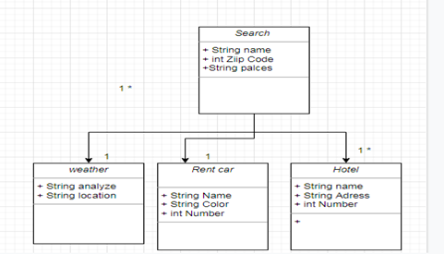

* **8.2 Class descriptions**

**<*Class name*>**

1.     **Abstract or Concrete:**

**List of Concrete Classes:**

1.     Login

2.     User

3.     Admin

4.     Tour Guide

5.     Booking

**List of Abstract Classes:**

1.     Ticket

2.     Weather Forecast

3.     Navigation

4.     Currency Converter

5.     Search

**Super class:**

Ø  Login is a super class

2.     **List of Subclasses:**Sub classes of search features

Ø  Hotel

Ø  Map

Ø  Weather

3.     **Purpose:**Search class is used to search multiple features of the project.

## 9. Preliminary Schedule

## The preliminary budget of this is that in first stage all requirements are gathering from all stakeholders. After gather requirements from stakeholder designing team working on design 2 to 4 week. Then implementation team works on first iteration 4 weeks. Completing first iteration immediately starts work on next iteration until the project is complete.

## 10. Preliminary Budget

The preliminary budget of this project is estimated 2million.



## 1-  Use Case Diagram.

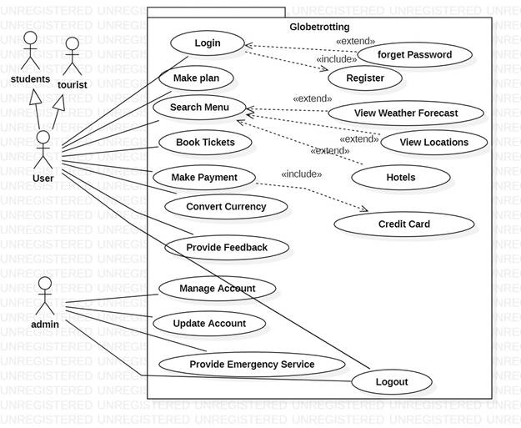

## 2- Fully dressed use cases:

Ø  Login:

|  |  |
| --- | --- |
| Use case name: | Login |
| Scope: | Login to the system |
| Level: | Level  1 |
| Primary Actors: | user |
| Stakeholder: | User should perform this task |
| Precondition: | User requirement name and password to enter |
| Post condition: | User can enter to the system |
| Main success scenario: | User can enter into the system |
| Extension: | If user Forget password the user can reset it. |
| Special requirements: | Special requirement for login are:  User name/user id ,user password |
| Technology requirements: | User can use mobile phone or laptop or desktop |

Ø  Convert Currency:

|  |  |
| --- | --- |
| Use case name: | Convert Currency |
| Scope: | System can convert currency for the foreign users |
| Level: | Level  5 |
| Primary actor: | User ,admin |
| Stakeholder: | User and system |
| Precondition: | User needs a currency converter |
| Post condition: | System can convert currency |
| Main success scenario: | Convert currency |
| Extension: | If user can’t provide same currency as system requires then payment will not be done. |
| Special requirement: | User must have bank account |
| Technologyrequirement: | Bank system, mobile phone and laptop |

Ø  **Use cases briefly describe:**

1.     **Login**:

User requires his Id no and his password to enter into the system after entering into the system he/she will plan his tours.

2.     **Make Plan**:

User can make plan through the system. User can check another planning as well as mentioned in the menu.

3.     **Book Tickets**:

User can buy tickets through cash or online payment.

4.     **Search Menu**:

User can know about the system that what should system provide to the user about the tour planning. Planning should be according to the users requirements.

5.     **Convert currency**:

This use case is for foreign because there currency may be different from us. If they can’t understand so they can’t use our system properly.

6.     **Provide feedback**:

This can be provided by the user to the system. It is helpful for the system that system can work properly or not. If feedback provided by the user is negative then system is failed.

7.     **Provide emergency service**:

If any type of emergency can come about the system or other then system should provide it to the users. It is helpful for the user and if user has any emergency then users also inform it to the system.

8.     **Manage account**:

System can manage account of user. There details (user name, user id etc) and many more option about users. Outside can’t access it without permission of system.

9.     **Update account**:

If user has others detail about himself and users want to save it in the system account then system will update the account.

10.  **Logout**: Logout the system through only one click and that is “Logout”.

## 3-List of Concrete Classes:

6.     Login

7.     User

8.     Admin

9.     Tour Guide

10.  Booking

## 4- List of Abstract Classes:

6.     Ticket

7.     Weather Forecast

8.     Navigation

9.     Currency Converter

10.  Search

*Scope of this project*

The Globetrotting project is an implementation of a managing Tourism which helps the customers to search the availability of various tourist places and prices of various hotel rooms in particular places, along with the different packages available with the reservations.

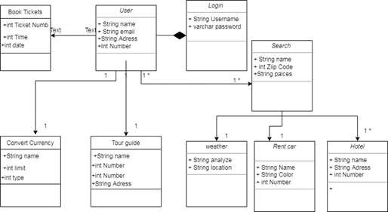

Domain Model

|  |  |
| --- | --- |
| **Use case name:** | **Login** |
| **Scope:** | **Login to the system** |
| **Level:** | **Level 1** |
| **Primary Actors:** | **user** |
| **Stakeholder:** | **User ,System** |
| **Precondition:** | **User requirement name and password to enter** |
| **Post condition:** | **User can enter to the system** |
| **Main success scenario:** | **User can enter into the system** |
| **Extension:** | **If user Forget password the user can reset it.** |
| **Special requirements:** | **Special requirement for login are:**  **User name/user id ,user password** |
| **Technology requirements:** | **User can use mobile phone or laptop or desktop** |

UseCase Model

* Fully Dress

UseCase of Login

|  |  |
| --- | --- |
| **Use case name:** | **Convert Currency** |
| **Scope:** | **System can convert currency for the foreign users** |
| **Level:** | **Level 5** |
| **Primary actor:** | **User ,admin** |
| **Stakeholder:** | **User and system** |
| **Precondition:** | **User needs a currency converter** |
| **Post condition:** | **System can convert currency** |
| **Main success scenario:** | **Convert currency** |
| **Extension:** | **If user can’t provide same currency as system**  **requires then payment will not be done.** |
| **Special requirement:** | **User must have bank account** |
| **Technologyrequirement:** | **Bank system, mobile phone and laptop** |

UseCase Model

* Fully Dress UseCase of Convert Currency

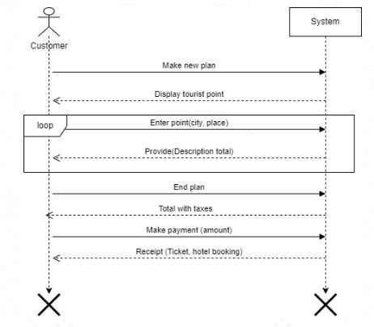

System Sequence Diagram

## System Sequence Diagram Generate Travel Plan:

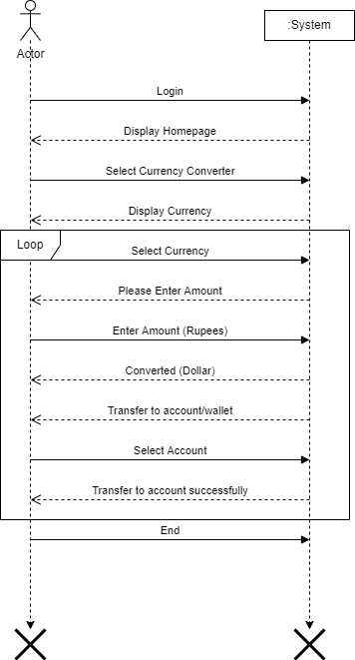

System Sequence Diagram

* ***System Sequence Diagram for Convert Currency***

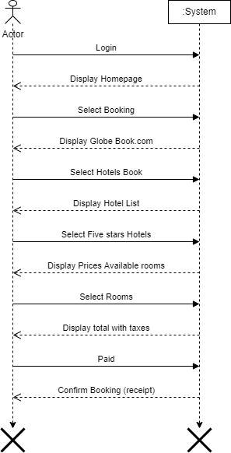

System Sequence Diagram

## System Sequence Diagram for Booking

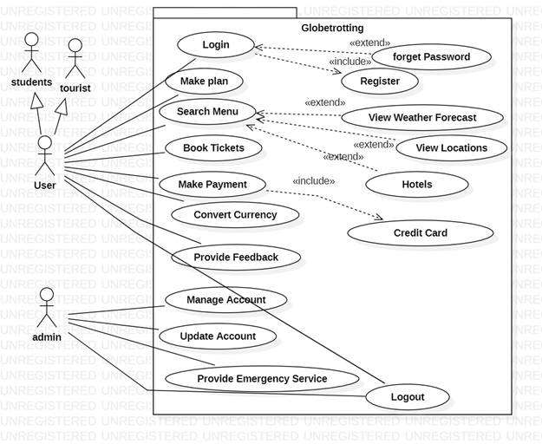

UseCase Diagram

Design Model

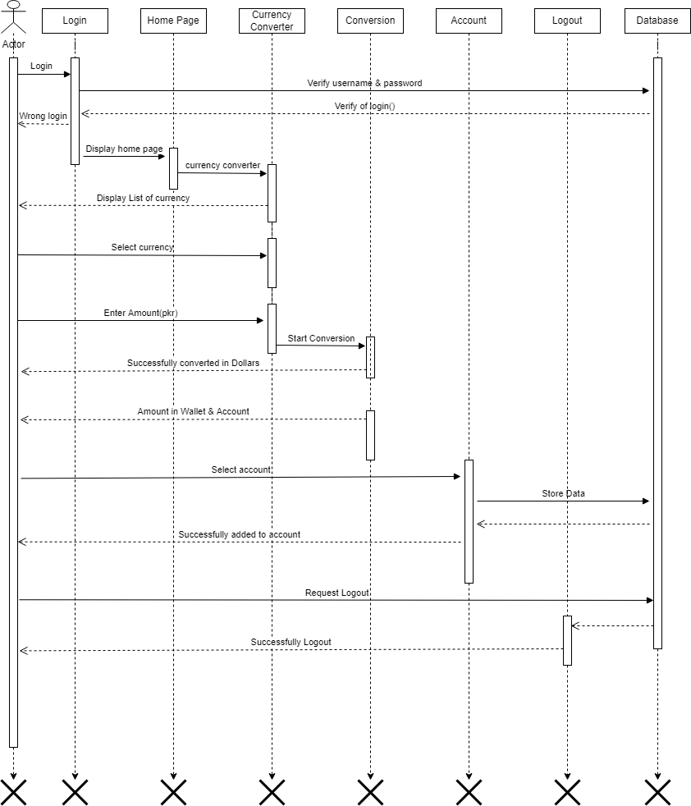

Sequence Diagram

Sequence diagram for Convert

Currency

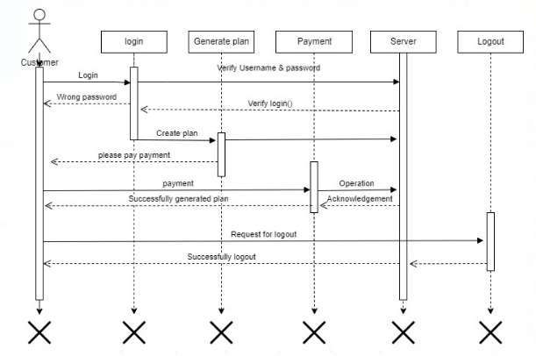

Sequence Diagram

Sequence diagram for Generate

plan

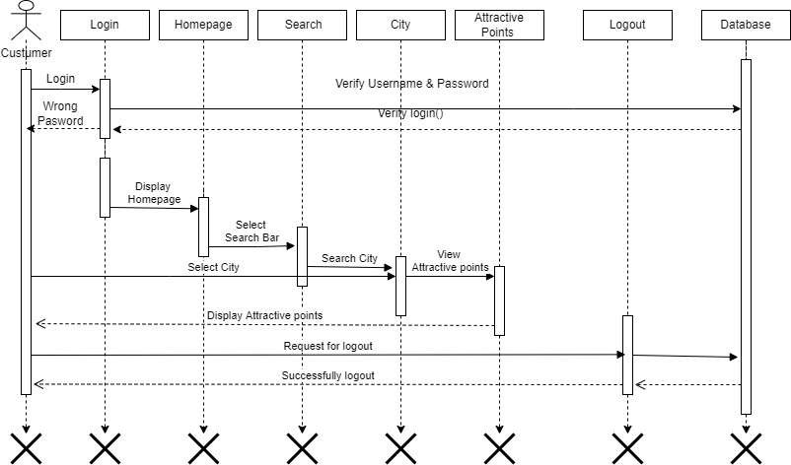

Sequence Diagram

Sequence diagram for Booking

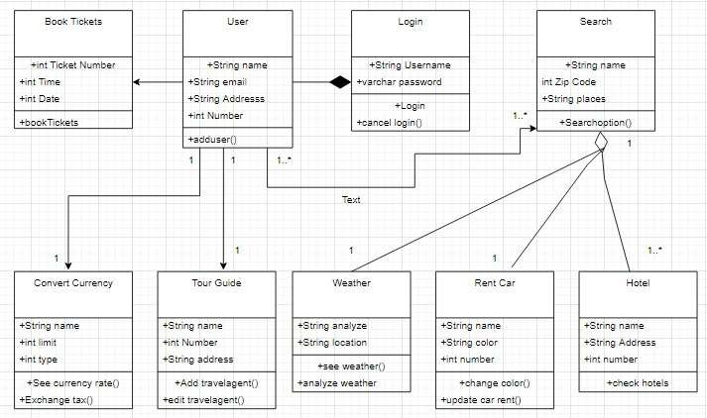

Class Diagram

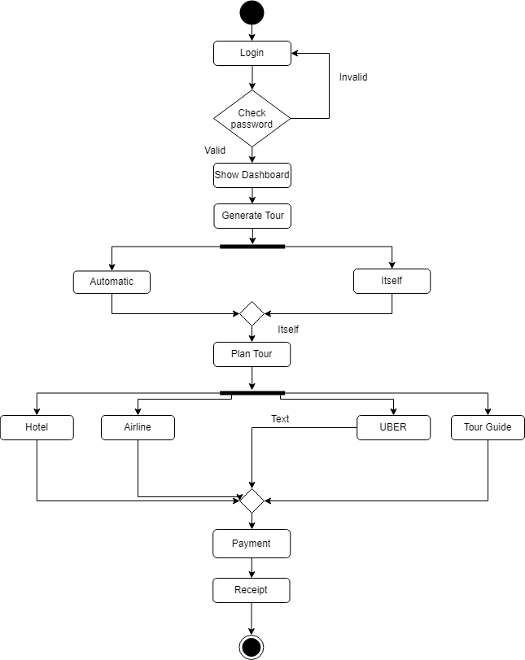

Activity Diagram

Activity diagram for Generate

Plan

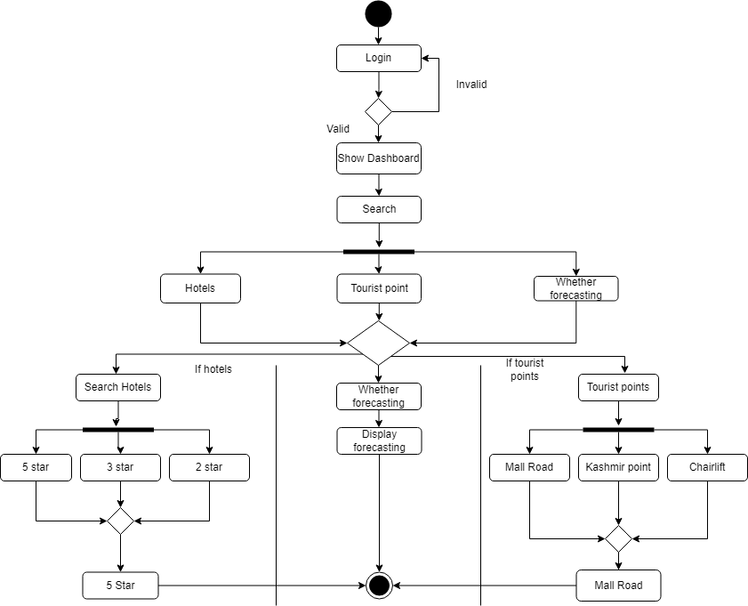

Activity Diagram

Activity diagram for Search

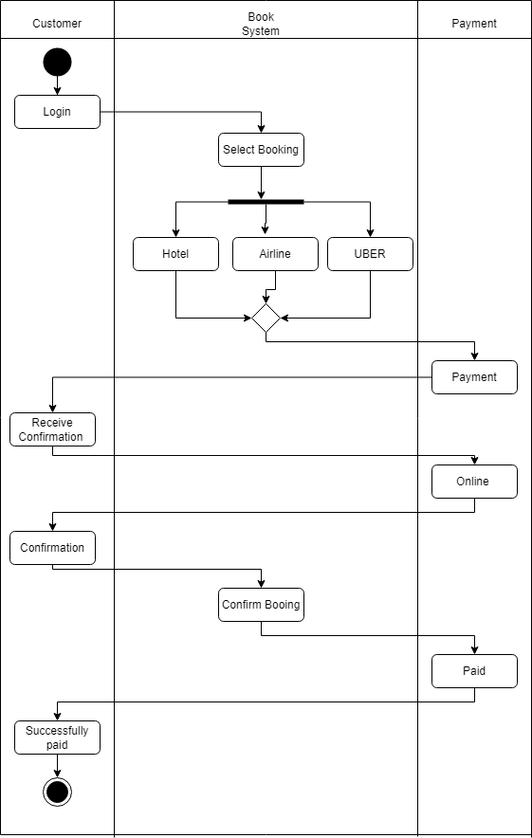

Activity Diagram

Activity diagram for Booking

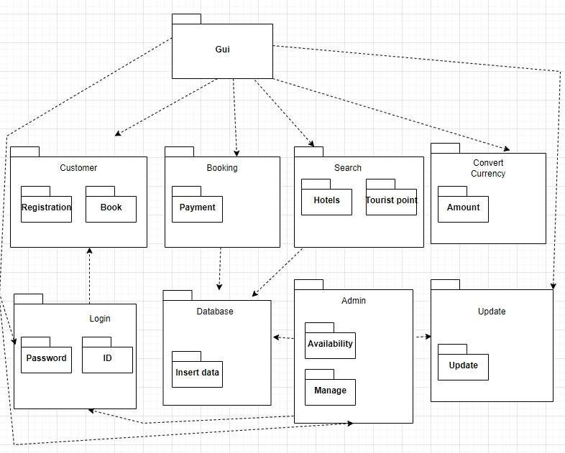

Package Diagram

Contract Operation 1

* + **Operation:**

convertcurrency(enteramount: interger,

currenecy)

* + **Cross Reference:** Usecase: Convertcurrency
  + **Precondition:** User will currency.

enter amount if he/she want to convert

**Post condition:** User will

have the currency that the system want he/she

will not have if

he/she want to visit somewhere.

Contract Operation 1

* + **Operation:** booking (enteramount of

booking: interger, Date:integer)

* + **Cross Reference:** Usecase: booking .
  + **Precondition:** There is booking

underway .

**Post condition:** A booking (b1) instance

was created.

b1 was associated with the current

booking.

b1 quantity became quantity.

b1 is associated with booking

description, bookingID date.

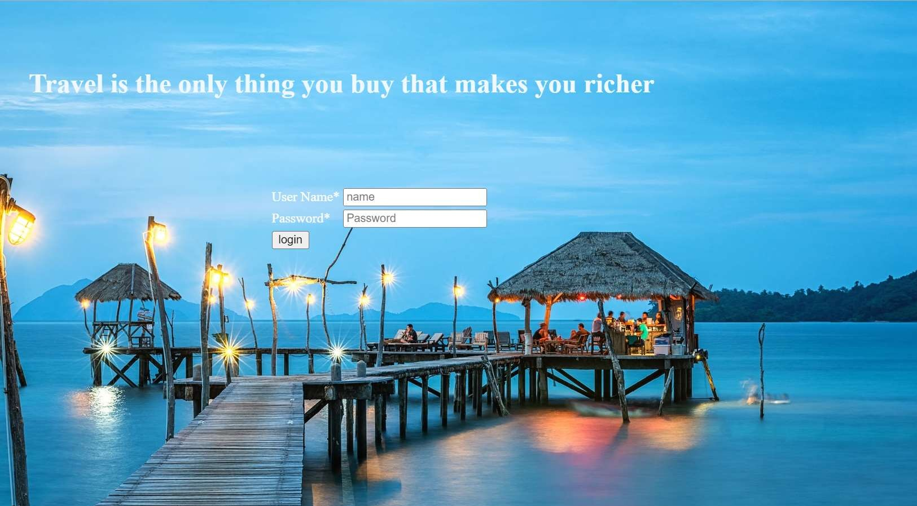

Login Page



Home Page

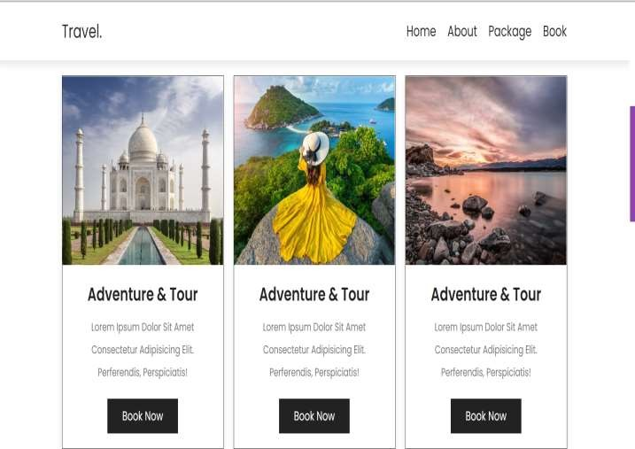

Package Page

Booking Page

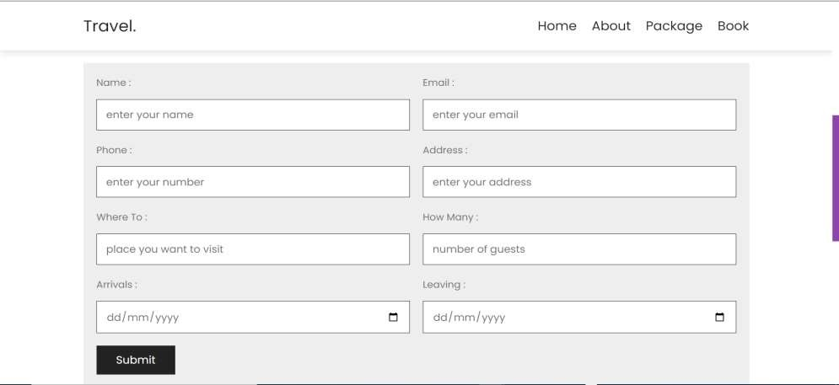

# Weather Page

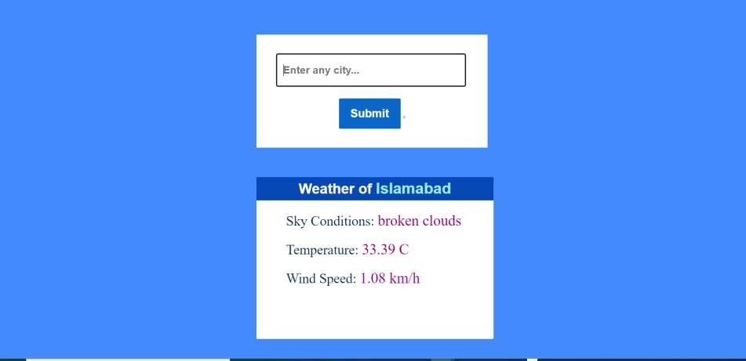

Payment Form

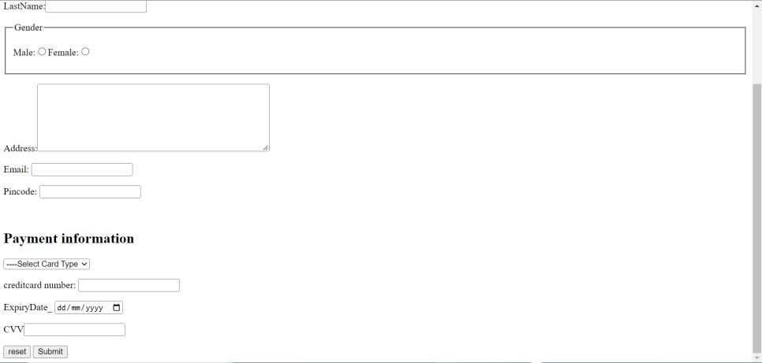

# Admin Interface

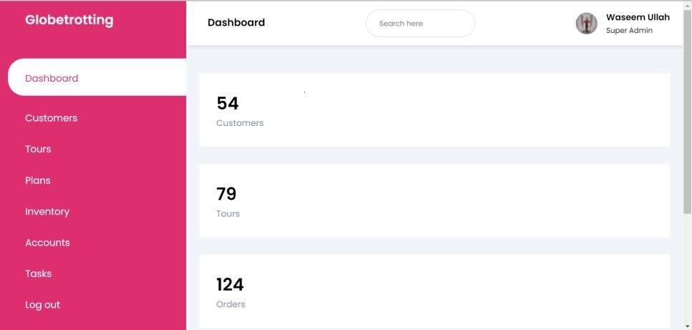

Convert Currency

